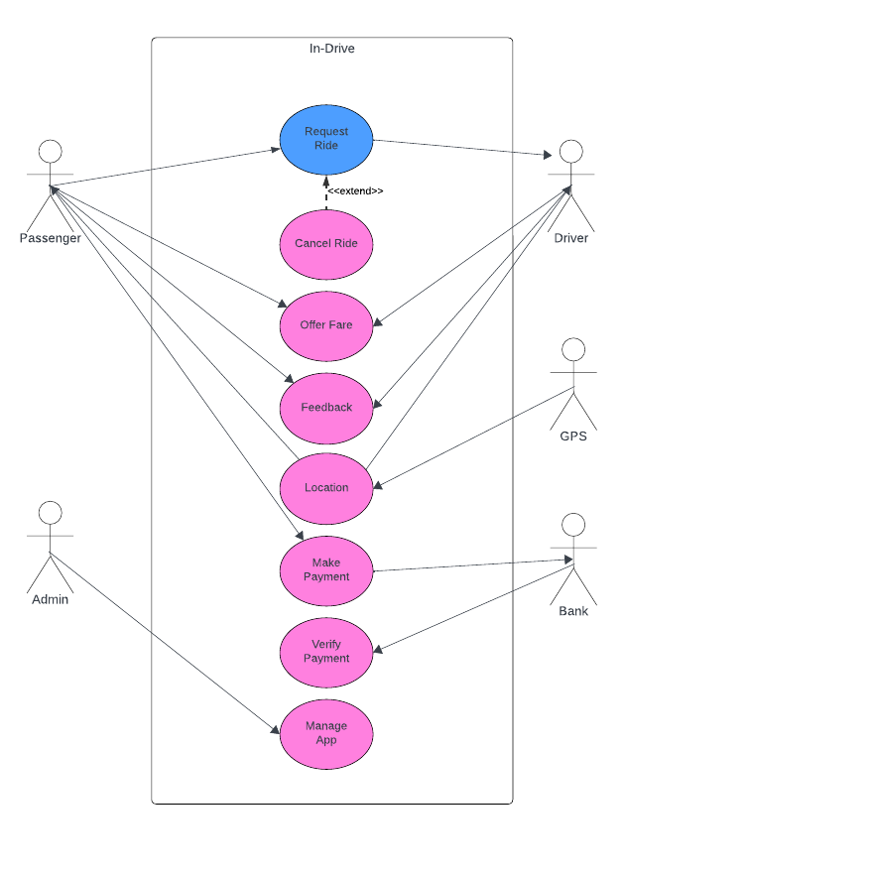USECASE DIAGRAM

USECASE DESCRIPTION

|  |  |
| --- | --- |
| ID and Name | UC-1 Request a Ride |
| Created By: | Dilawar and Team Date Created:18/11/2023 |
| Primary Actor: | Passenger Secondary Actor: Driver |
| Description: | The Passenger requests a ride of his desired choice. The system will find a ride according to the passengers needs and will forward the request of passenger to the driver of the ride. The passenger can also cancel the ride if incase he changes his mind. |
| Trigger | The passenger indicates that he wants a ride. |
| PreConditions | PRE-1. Passenger’s ID has been authenticated  PRE-2. Passenger’s location is valid and is inside the range of the app. |
| PostConditions | POST1- Passenger’s Request is stored in Indrive database.  POST2- Passenger’s Request is sent to driver. |
| Normal Flow | 1. **Request for a ride** 2. Passenger requests for his desired ride. 3. System shows the available rides related to the passenger’s request. 4. Passenger chooses a ride. 5. System stores the information and sends a ride request to the selected driver. |
| Alternative Flow | **1.1 Passenger Cancels the ride**   1. Passenger cancel the ride during the process. 2. The system returns back to it’s home page. 3. The passenger can request for a new ride. |
| Exception | **1.1.E1 No Rides are available**  1- The system displays error message that no rides are currently available.  2- System asks passenger if he wants to be notified when a ride is available in his location.  3- System asks passenger if he wants to schedule a ride for later.  4- System returns to home screen. |
| Priority | High |
| Frequency | Approximately 200 times a day |
| Business Rules | BR-1 |

|  |  |
| --- | --- |
| ID and Name | UC-2 Offer a fare |
| Created By: | Dilawar and Team Date Created:18/11/2023 |
| Primary Actor: | Passenger Secondary Actor: Driver |
| Description: | The Passenger offers a fare of his own choice. The offered fare is stored in the system and is sent to the driver. If the fare is accepted by both driver and the passenger, the fare price will be confirmed, otherwise the ride will be automatically canceled. |
| Trigger | The passenger indicates he wants to offer a fare. |
| PreConditions | PRE-1. Passenger’s ID has been authenticated.  PRE-2. Passenger’s location is valid and is inside the range of the app.  PRE-3. Passenger has offered a valid fare. |
| PostConditions | POST1- Passenger’s fare is stored in Indrive database.  POST2- Passenger’s fare is sent to driver.  POST3- Passenger gets feedback from the driver. |
| Normal Flow | 1. **Fare accepted by driver**   1- The fare offered by the passenger is accepted by the driver or the driver offers his own fare.  2- Fare is confirmed by negotiation. |
| Alternative Flow | **2.1 Fare is rejected by driver**  1- Either the driver rejects fare or the passenger rejects fare.  2-The ride is canceled.  3-Passenger will be asked to select another ride |
| Exception | **2.1.E1 Invalid fare**  1- The system displays error message that the fare offered is too high or too low.  2- The user will be asked to re-enter a new fare. |
| Priority | High |
| Frequency | Approximately 200 times a day |
| Business Rules | BR-2 |

|  |  |
| --- | --- |
| ID and Name | UC-3 Send Location |
| Created By: | Dilawar and Team Date Created:18/11/2023 |
| Primary Actor: | GPS Secondary Actor: Passenger, Driver |
| Description: | When a passenger requests a ride, the GPS will automatically retrieve the exact location of passenger and will share the location with rider. Similarly, the driver’s location (accuracy up to 5 meters) will be shared with the passenger. |
| Trigger | The passenger requests a ride. |
| PreConditions | PRE-1. Passenger’s ID has been authenticated.  PRE-2. Passenger’s allows GPS to track his location. |
| PostConditions | POST1- Passenger’s location is shared with driver.  POST2- Driver’s location is shared with passenger. |
| Normal Flow | 1. **Accurate location is shared**   1- The Passenger allows the app to share his location with driver.  2- The Driver allows to share his location with passenger. |
| Alternative Flow | **3.1 Location is not shared**  1- Either the driver does not allow the app to share his location or either passenger does not allow to share his live location.  2- The passenger or driver will be asked to enter there location manually through address. |
| Exception | **3.1.E1 Invalid Location**  1- The location shared by the passenger is out of the range of app.  2- An error message will be displayed that this location is out of our range. |
| Priority | High |
| Frequency | Approximately 200 times a day |
| Business Rules | BR-3 |

|  |  |
| --- | --- |
| ID and Name | UC-4 Give Feedback |
| Created By: | Dilawar and Team Date Created:18/11/2023 |
| Primary Actor: | Passenger, Driver Secondary Actor: Passenger, Driver |
| Description: | After the ride is completed, the passenger and driver will be given the opportunity to rate each other and give feedback to each other |
| Trigger | The ride is completed. |
| PreConditions | PRE-1. The ride is completed  PRE-2. Payment is done. |
| PostConditions | POST1- feedback and ratings given to driver are stored in app’s database.  POST2- feedback and ratings given to passenger are stored in app’s database. |
| Normal Flow | 1. **Feedback is posted**   1- The Passenger gives proper feedback to the driver.  2- The driver gives proper feedback to the passenger. |
| Alternative Flow | **4.1 Refuse to give feedback**  1- Either the driver refuses to give feedback to passenger or either passenger refuses to give feedback to the driver.  2- The ride session will be ended and the system will go to the homepage. |
| Exception | **4.1.E1 Feedback is given before completion of a ride.**  1- An error message will be displayed that feedback can only be given once a ride is completed. |
| Priority | Low |
| Frequency | Approximately 200 times a day |
| Business Rules | BR-4 |

ACTIVITY DIAGRAM

Request Ride

Display an error

Message

Return to the home page

Stores the information and send to the selected driver.

Want to cancel

the ride

Passenger chooses a ride

Show Available ride

Ride available?

No

Yes

No

Ride begins

Yes

Valid input?

Display Error message

Yes

No

Passenger Offer fare

No

Yes

System Store fares

Fares Confirmed

Passenger is notified that fares is rejected

Passenger can offer new fares

Is Fares

Accepted?

Allow app to share location

Driver manually input the location

No

Passenger manually input the location

Yes

Passenger allows the app to share his location with driver

Invalid

location

Display Error message

No

Driver allows the app to share his location with passenger

Yes

Invalid

location

Location is out of the Range

Location is shared

No

Ride Complete

Payment Done

Ride End

Yes

No

Driver gives feedback to Passenger.

Passengers give feedback to Driver.

Want to give the feedback

Return to the home page